**­CSC 1101 – Problem Solving and Programming Laboratory – Winter 2019**

**Lab 17 – (student name)**

**25 points – Due March 26, end-of-class**

**a)** Save this document with your name and the lab assignment number somewhere in the file name.

**b)** Type/paste your answers into the document.

c) Submit this document and your .cpp file(s) to the Canvas item where you downloaded this document. Do not submit a zip file but individually attach your files.

<https://canvas.wayne.edu/courses/99440/assignments/720035>

Create a copy of the C++ template file. Write a C++ console application and do the following:

1. Rename the copy you made to **yourName_InClass_Lab17.cpp** and save it into your *CSC1101* folder.
2. Complete the header comment.
3. Modify the application header and close to contain the application name.
4. Define an enumerator type **grades** that contains the values **A=90, B=80, C=70, D=60, F=50**.
5. Prompt the user for a first name and store the value into a **String variable**.
6. Prompt the user for a last name and store the value into a different **String variable**.
7. Using a third **String variable** combine the two previous Strings with a space between them. Hint: (… = … + ‘ ’ + ...)
8. Prompt the user for a grade and store the value into a **Char variable**.
9. Declare a **grades variable** and using a switch statement match the user entered grade with the **grades** enumerator equivalent. Hint: (case 'A': yourgradesvariable = A; break;)
10. Print out the combined **String variable** and the **grades variable**. Format it to match the sample output.

Sample Output

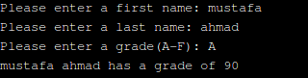

*[your program code here]\**

**If possible, format your code like this:**

**//==========================================================**

**//**

**// Title: Grade Boi**

**// Course: CSC 1101**

**// Lab Number: Lab 17**

**// Author: Trevor Trusty**

**// Date: 3/26/2019**

**// Description:**

**// Takes students name and whole grade letter, and prints**

**// whole number percent grade**

**//==========================================================**

**#include <conio.h> // For function getch()**

**#include <cstdlib> // For several general-purpose functions**

**#include <fstream> // For file handling**

**#include <iomanip> // For formatted output**

**#include <iostream> // For cin, cout, and system**

**#include <string> // For string data type**

**using namespace std; // So "std::cout" may be abbreviated to "cout"**

**//==========================================================**

**// Globals**

**//==========================================================**

**// Enumerated types**

**enum grades{A = 90, B = 80, C = 70, D = 60, F = 50};**

**// Constants**

**const char p = ' '; // Blank whitespace character**

**// Prototypes**

**void makeLower(char);**

**grades toGrades(char x);**

**int main()**

**{**

**// Declare variables**

**char grade;**

**grades gradeLetter;**

**string firstName, lastName;**

**string fullName;**

**// Show application header**

**cout << "Welcome to Grade Boi!" << endl;**

**cout << "--------------------------" << endl << endl;**

**// Read from console**

**cout << "Enter first name: ";**

**cin >> firstName;**

**cout << "Enter last name: ";**

**cin >> lastName;**

**fullName = firstName + p + lastName;**

**cout << "Enter student's letter grade: ";**

**cin >> grade;**

**grade = tolower(grade);**

**gradeLetter = toGrades(grade); //Convert grade char to enum defined variable**

**// Write to screen**

**cout << fullName << " has a grade of " << gradeLetter << endl;**

**// Show application close**

**cout << "\nEnd of Grade Boi" << endl << endl;**

**// Pause before application window closes**

**cout << "Press any key to exit ..." << endl;**

**_getch();**

**}**

**//==========================================================**

**// toGrades**

**//==========================================================**

**grades toGrades(char x)**

**{**

**switch (x)**

**{**

**case 'a':**

**return A;**

**break;**

**case 'b':**

**return B;**

**break;**

**case 'c':**

**return C;**

**break;**

**case 'd':**

**return D;**

**break;**

**case 'f':**

**return F;**

**break;**

**}**

**}**

*[your program output here]\*\**

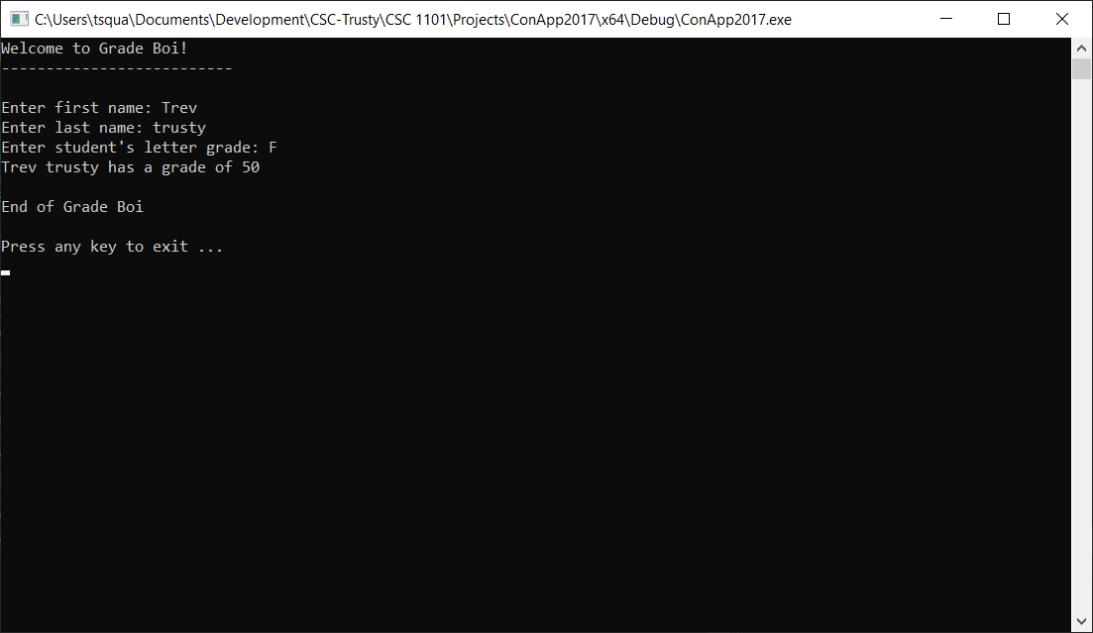

* **Copying-and-pasting Visual C++ code to a Word document**

1) From within the Visual C++ program, press **CTRL-A** and press **CTRL-C**.

2) From within the Word document, press **CTRL-V**.

** **Copying-and-pasting Visual C++ console application output to a Word document**

1) From the Visual C++ console, press **ALT-PrintScreen**.

2) From within the Word document, press **CTRL-V**.